the JCEC TOUR
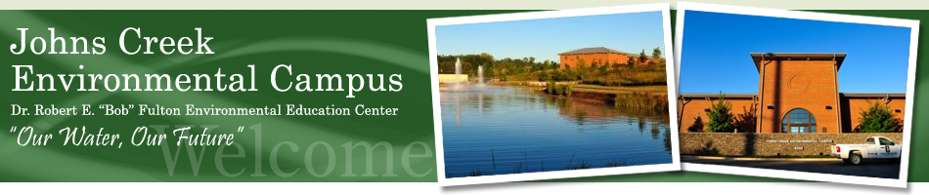
When: Friday April 18th @1:00-2:30pm
Who: Calling all students, staff, and faculty at Georgia Perimeter College
REGISTER HERE BY APRIL 11th: http://alpharettasego.weebly.com/jcec-tour-info.html
Or Register for the GPC tour by contacting the President and activity leader Alex Gordon:
678.468.2734 or gordonag@student.gpc.edu

  - WHERE: It is located at 8100 Holcomb Bridge Road, Alpharetta, GA 30022. Bring: A notebook, a pen, and questions.
  - INFO: The JCEC is one of the top 10 largest water reclamation plants in the United States and here they are using the latest bio-reactor membrane technology to clean our increasingly toxic waste water. The results have been startling. Capable of purifying water so well that it comes out with a bottled water quality consistency, this reclamation facility is truly one of a kind. Purifying up to 15 million gallons per day, this hidden powerhouse facility is one of a kind. Waste water that gets treated here is processed, aerated with dissolved oxygen (ecologically important), and returned into the Chattahoochee River to keep our sensitive aquatic environment’s oxygen sensitive organisms from being oxygen deprived by pollutants generated from the rapidly developing city of Atlanta. The plant will supply the western end of North Fulton County – Johns Creek entirely and parts of Alpharetta and Roswell with all of their water needs through their developmental build-out (Gordon, 2013).

